|  |
| --- |
| **BAKERY MANAGEMENT SYSTEM**  **21CSS101J – PROGRAMMING FOR PROBLEM SOLVING**  **Mini Project Report**  *Submitted by*  **SHREYANSH KHANDELWAL [Reg. No.: RA2211003010387]**  **Btech. CSE - CORE**  **HARSHIT NOTANI [Reg. No.: RA2211003010388]**  **Btech. CSE - CORE**  **SRMIST-01.jpg**  **SCHOOL OF COMPUTING**  **COLLEGE OF ENGINEERING AND TECHNOLOGY**  **SRM INSTITUTE OF SCIENCE AND TECHNOLOGY**  **(Under Section 3 of UGC Act, 1956)**  S.R.M. NAGAR, KATTANKULATHUR – 603 203  KANCHEEPURAM DISTRICT  **December 2022** |

TABLE OF CONTENTS

|  |  |  |
| --- | --- | --- |
| **Chapter No.** | **Title** | **Page No.** |
| 1 | Problem Statement |  |
| 2 | Methodology / Procedure |  |
| 3 | Coding (C or Python) |  |
| 4 | Results |  |
| 5 | Conclusion |  |

PROBLEM STATEMENT

Bakeries which have several branches and has expanded business model faces lot of problems regarding to it sales report, profit, stock left, etc. It lacks an organized management that can run their business with transparency. It becomes difficult for bakery which has branches all over the state to supervise every branch of it.

Staff working in this bakery also faces difficulty to serve their customers properly as it becomes almost impossible to remember the product availability in such a huge bakery, as a result even if the product is available then also the customer leaves the shop unsatisfactory.

Many such problem are faced by bakery daily, so to vanish this problem a customized bakery management system is needed in order to run the bakery in a proper organized manner.

METHODOLOGY/PROCEDURE

The main purpose of this software project is to automate the functionalities of a bakery store. This software project is developed to automate the record of the different items, sales, graphical analysis, and profit with a view to enhance the decision making of the functionaries.

A BMS is mainly consist of a computerized database, a collection of interrelated tables for a particular subject or purpose, capable to produce different reports relevant to the user. An application program is tired with the database for easy access and interface to database. Using application program or front end, we can store, retrieve and manage all information in proper way.

Problem definition and analysis of the activity that encompasses. Earning about the problem to be solved, understanding the needs of customer and users, trying to find out who the user really is and understanding all the constraints on the solution. It includes all activities related to the following.

* Identification and documents of customer’s or user’s need.
* Creation of a document that describes the external behavior and association constants that will satisfy those needs.
* Analysis and validation of the requirements documents to ensure consistency, completeness and feasibility.
* Evolution of needs.

After the analysis of functioning of a bakery store, the Proposed System is expected to the following.

* To provide a user friendly, best integrated and centralized environment for computerized bakery store.
* The proposed system should maintain all the records and transaction and should generate the required report and information when required.
* To provide efficient and secured information storage flow and retrieval system, ensuring the integrity and validity of records.
* To provide user friendly interface to interact with a centralized database based on client server architecture.
* To identify the critical operation, procedure and possibilities of simplification using modern IT tools and practices.

This software being simple in design and working, does not require much of training to users and can be used as a powerful tool for managing a big bakery.

To execute this project we completed the following tasks:

1. Conducted many reviews from the bakery owners and staff that what basic problems they face while running the bakery.
2. According to the reviews we made the owner understand that what they need to change and what not to.
3. We found staff who knew how to operate a computer.
4. Prepared a model based on the reviews.
5. Identified the resources available.
6. Build the software application in easy way so that everyone can use.
7. Trained the staff to use the software application.
8. Developed an action plan and strategic marketing planning.
9. Submitted the report.

For building the software application we used the most basic language python. The python language is one of the most accessible programming languages available because it has simplified syntax and not complicated, which gives more emphasis on natural language. Due to its ease of learning and usage, python codes can be easily written and executed much faster than other programming languages.

Project Result: Many of the bakery owners were able to run their bakeries in a more convenient and efficient way without worrying about the collection of database and managing the staff altogether.

Sample of Files Used:

B1.csv

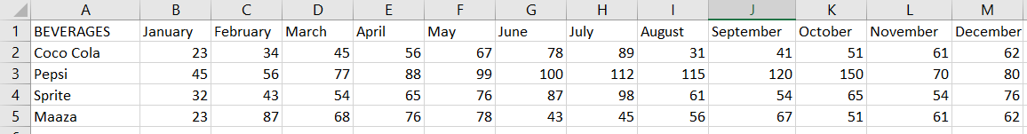

Cakes.csv

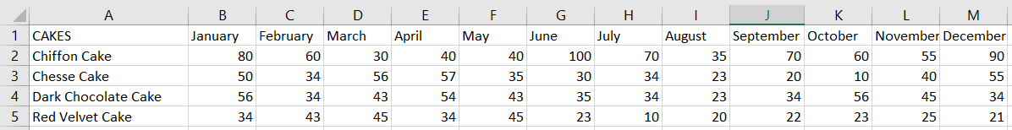

Snacks.csv

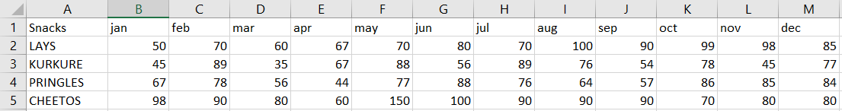

Book1.xlsx Book11.csv

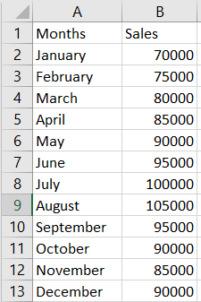 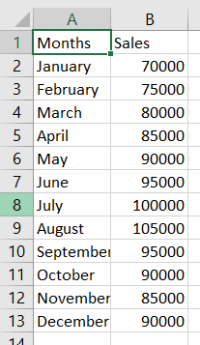

SOURCE CODE

import time,sys,os,maskpass,pyfiglet

from yachalk import chalk

from InquirerPy import inquirer

msg="WELCOME TO THE BAKERY MANAGEMENT SYSTEM"

print(pyfiglet.figlet_format(msg, font="digital"))

for char in msg:

sys.stdout.write(chalk.blue.bg_magenta_bright.bold.italic.underline(char))

time.sleep(0.05)

time.sleep(0.2)

import pandas as pd

import matplotlib.pyplot as plt

print()

n1=0

n7=input(chalk.bg_cyan_bright('ENTER YOUR NAME:\n'))

n8=0

n8=maskpass.advpass(prompt=chalk.bg_cyan_bright("ENTER THE PASSWORD:"),mask="*")

while n8!='qwerty':

print(chalk.rgb(255,87,51).bold("TRY AGAIN!!!!"))

n8=maskpass.advpass(prompt=chalk.bg_cyan_bright("ENTER THE

PASSWORD:"),mask="*")

print("---------------------------------------------------------------------------------------------------------------------------")

while n1!="Exit The System":

print("---------------------------------------------------------------------------------------------------------------------------")

print("---------------------------------------------------------------------------------------------------------------------------")

n1 = inquirer.select(

message="SELECT YOUR CHOICE",

choices=["The Sales Report", "The List of Items in Shop", "Update the

List of Items in Shop", "Profit Calculator","The Maximum,Minimum,Total

of the Sales","Exit The System"],).execute()

print("---------------------------------------------------------------------------------------------------------------------------")

if n1=="The Sales Report":

df=pd.read_csv("Book11.csv")

df.plot(kind='bar',color='Yellow',edgecolor='Black',

linestyle='dashed',linewidth=1)

ticks = df.index.tolist()

plt.xticks(ticks,df.Months)

plt.title('MONTHLY SALES REPORT')

plt.ylabel('Sales(in Rs)')

plt.xlabel('Months')

plt.grid(True)

plt.show()

elif n1=="The List of Items in Shop":

print("---------------------------------------------------------------------------------------------------------------------------")

n2=inquirer.select(message="SELECT YOUR CHOICE",choices=["CAKES",

"SNACKS" , "BEVERAGES"],).execute()

print("---------------------------------------------------------------------------------------------------------------------------")

if n2=="CAKES":

Cakes=pd.read_csv("cakes.csv")

print(Cakes)

elif n2=="SNACKS":

Snacks=pd.read_csv("snacks.csv")

print(Snacks)

elif n2=="BEVERAGES":

Beverages=pd.read_csv("B1.csv")

print(Beverages)

else:

print(chalk.red_bright('VALUE ERROR! PLEASE CHECK'))

elif n1=="Update the List of Items in Shop":

import os

print("---------------------------------------------------------------------------------------------------------------------------")

n3=inquirer.select(message="SELECT YOUR

CHOICE",choices=["CAKES","SNACKS","BEVERAGES"],).execute()

print("---------------------------------------------------------------------------------------------------------------------------")

if n3=="CAKES":

os.system("start cakes.csv")

elif n3=="SNACKS":

os.system("start snacks.csv")

elif n3=="BEVERAGES":

os.system("start B1.csv")

print("---------------------------------------------------------------------------------------------------------------------------")

else:

print(chalk.red_bright('VALUE ERROR! PLEASE CHECK'))

elif n1=="Profit Calculator":

print("---------------------------------------------------------------------------------------------------------------------------")

n3=inquirer.select(message="SELECT YOUR CHOICE",choices=["To Get

the Net Profit", "To Get Profit Per Item"],).execute()

print("---------------------------------------------------------------------------------------------------------------------------")

if n3=="To Get the Net Profit":

c1=int(input(chalk.bg_cyan_bright("Enter the Number of Cakes

Sold:\n")))

c2=int(input(chalk.bg_cyan_bright("Enter the Number of Snacks

Sold:\n")))

c3=int(input(chalk.bg_cyan_bright("Enter the Number of

Beverages Sold:\n")))

print(chalk.bg_blue("Net Profit= Rs",(c1*50)+(c2*20)+(c3*60)))

elif n3=="To Get Profit Per Item":

n4=inquirer.select(message="SELECT YOUR

CHOICE",choices=["CAKES","SNACKS","BEVERAGES"],).execute()

if n4=="CAKES":

n5=int(input(chalk.bg_cyan_bright("Enter the Number of

Cakes Sold:\n")))

print(chalk.bg_blue("Net Profit is=Rs",n5*50))

elif n4=="SNACKS":

n6=int(input(chalk.bg_cyan_bright("Enter the Number of

Snacks Sold:\n")))

print(chalk.bg_blue("Net Profit is=Rs",n6*20))

elif n4=="BEVERAGES":

n7=int(input(chalk.bg_cyan_bright("Enter the Number of

Beverages Sold:\n")))

print(chalk.bg_blue("Net Profit is=Rs",n7*60))

else:

print(chalk.red_bright('VALUE ERROR! PLEASE CHECK'))

print("---------------------------------------------------------------------------------------------------------------------------")

elif n1=="The Maximum,Minimum,Total of the Sales":

print("---------------------------------------------------------------------------------------------------------------------------")

df = pd.read_excel("Book1.xlsx")

print(chalk.bg_blue("Net Sales:Rs",df["Sales"].sum()))

time.sleep(0.4)

print()

print(chalk.bg_blue("Maximum Sales with Month:\n",df.max()))

time.sleep(0.4)

print()

print(chalk.bg_blue("Minimum Sales With Month:\n",df.min()))

elif n1=="Exit The System":

os.system('cls')

time.sleep(1)

print("---------------------------------------------------------------------------------------------------------------------------")

print("---------------------------------------------------------------------------------------------------------------------------")

print(chalk.magenta("THANK

YOU"),chalk.rgb(255,0,255).bold.italic(n7),chalk.magenta("FOR USING

BAKERY MANAGEMENT SYSTEM......."))

print("---------------------------------------------------------------------------------------------------------------------------")

print("---------------------------------------------------------------------------------------------------------------------------")

else:

print(chalk.red_bright('VALUE ERROR! PLEASE CHECK'))

if n8!='qwerty':

print(chalk.rgb(255,87,51).bold("TRY AGAIN!!!!"))

RESULT

1)

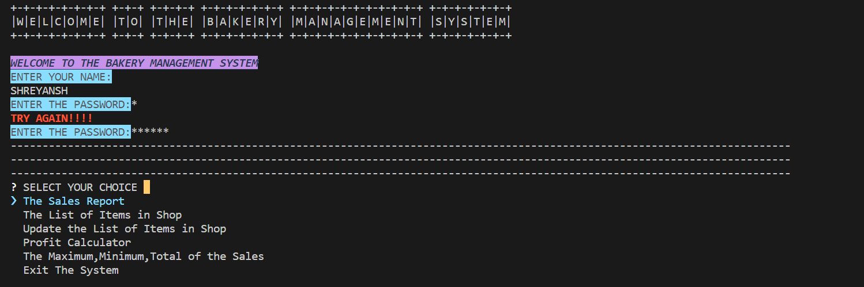

2) IF CHOISE IS: THE SALES REPORT

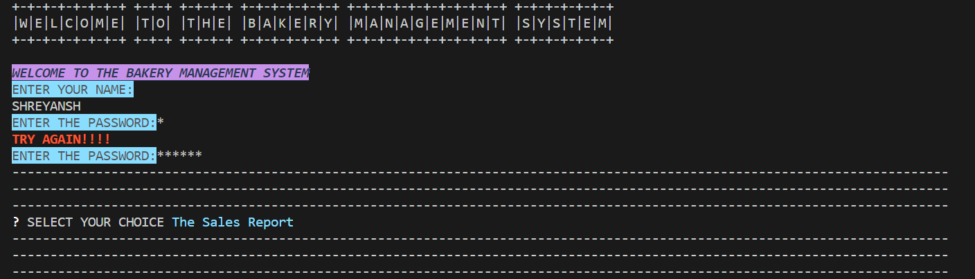

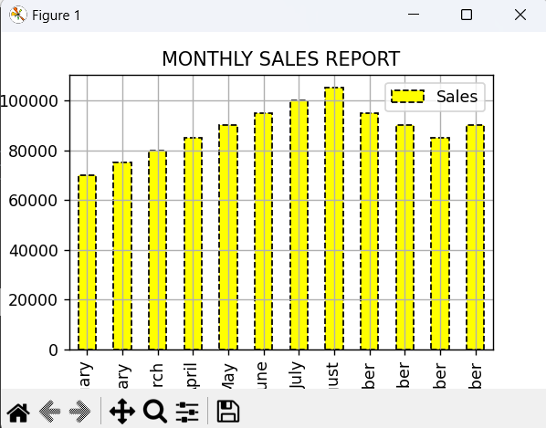

3) IF CHOISE IS: THE LIST OF ITEMS IN SHOP

1. CAKES

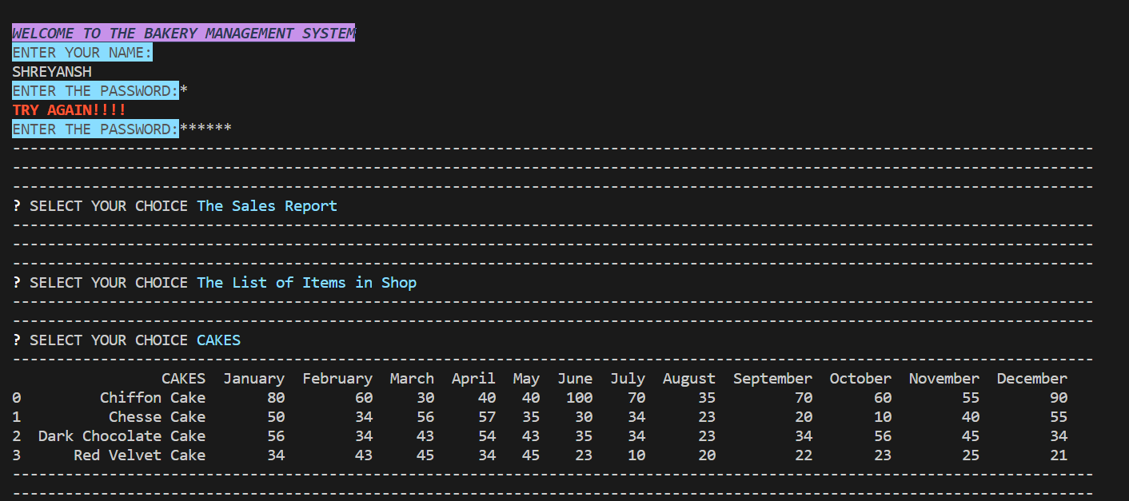

1. SNACKS

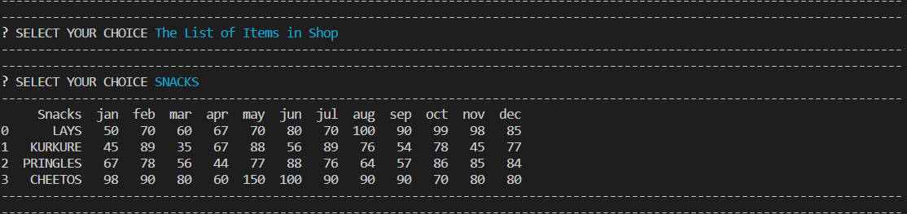

1. BEVERAGES

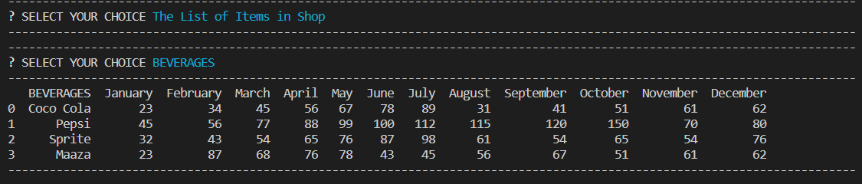

4) IF CHOISE IS: UPDATE LIST OF ITEMS IN SHOP

1. SNACKS

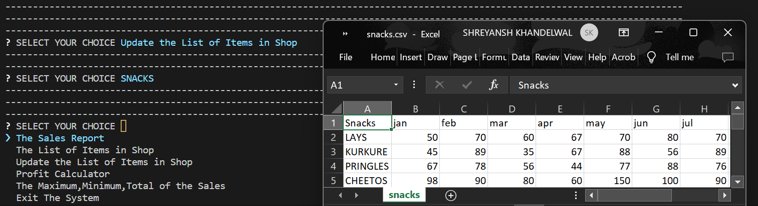

1. CAKES

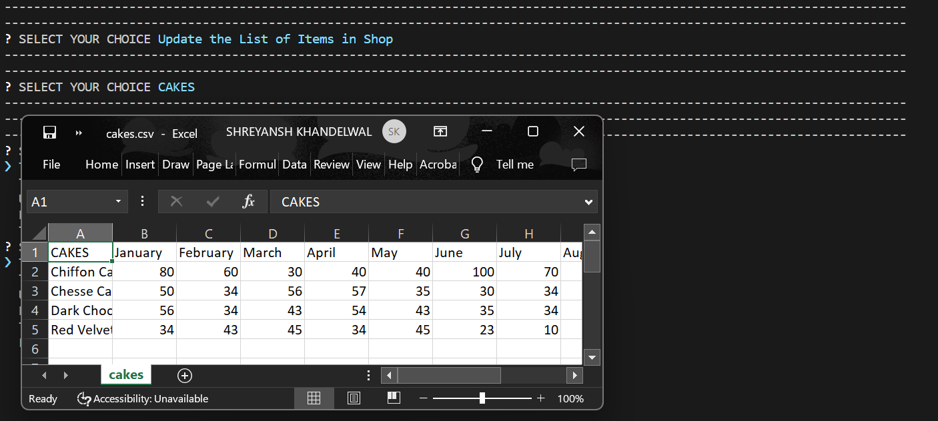

1. BEVERAGES

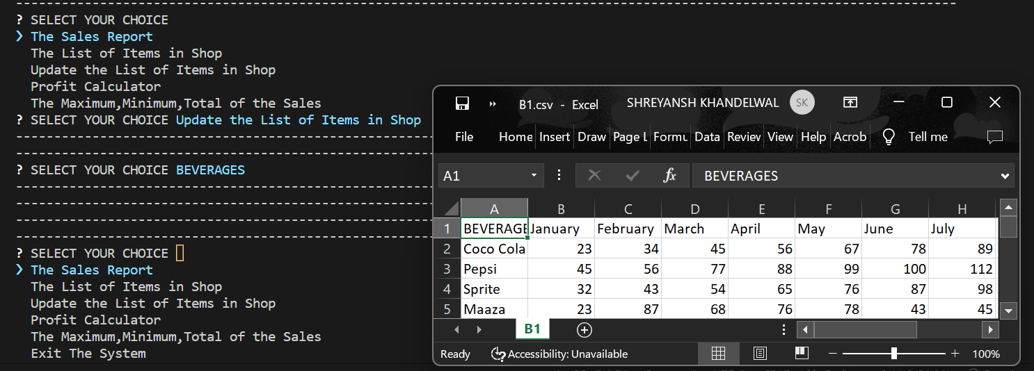

5) IF CHOISE IS: PROFIT CALCULATOR

1. NET PROFIT

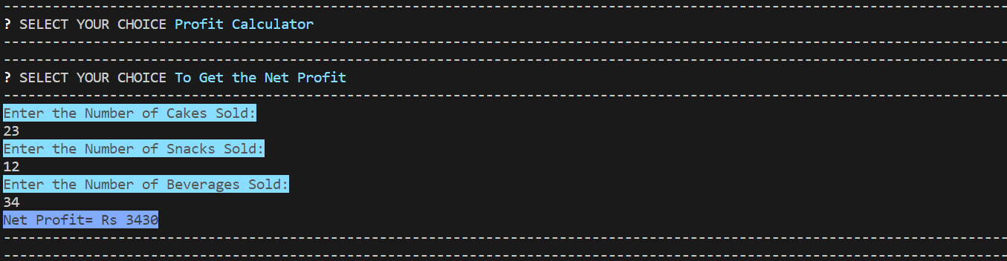

1. PROFIT PER ITEM

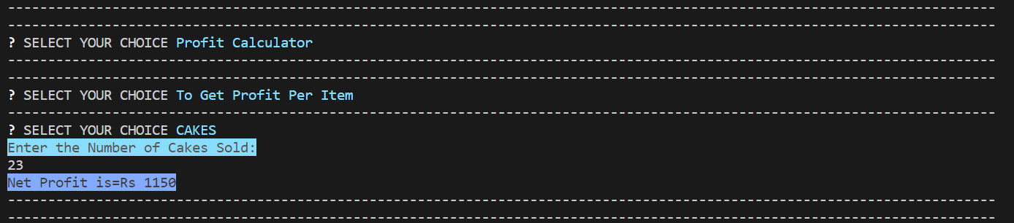

6) IF CHOISE IS: MAXIMUN, MINIMUM AND TOTAL OF SALES

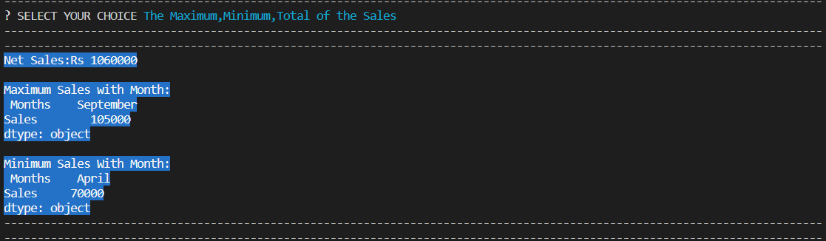

7) IF CHOISE IS: EXIT THE SYSTEM



CONCLUSION

Conclusion On overall, the project has achieved its objectives. The project has provided a client/server application for managing a bakery and was successfully built using Visual Studio software. It provides a more convenient and accurate method for staff in the shop since now managing the database is more effective and convenient for everyone. In view of time saving, less time consuming than waiting and collecting database in papers. In other words, this can minimize the time, money and storage of the database.

Apart from using internet application, it can be extended using Bluetooth technology. Thus working on voice commands making the application more simplistic and robust.

There are some possible improvement that can be performed to the system in the future. Develop a proper database that can link directly to both client and owner Interface for monthly payments.

Add more function button to provide variety function of system and making it more automated for simple use.